Abstract Template for 21st International SPACC Symposium
Office Use
and 1st Innovation Forum of Advanced Engineering and Education
A. Author,^{1,}* B. Author,¹ and C. Author²
¹ The Author affiliation, department, city, Country
² The Author affiliation, department, city, Country if different
*E-mail: your_address@xx.xxxx.xxx

The authors are encouraged to submit a camera-ready abstract [A4-size (210 x 297 mm) with margins described in Fig. 1, or within a frame of 170 x 240 mm]. The abstract must be written in English. Use Times New Roman font. In the PDF file case, all fonts should be embedded in the file. The font size should be boldfaced 14 point for the title. The presenter name must be underline. Text must be typed with a Times New Roman, single spacing, 12 pt in regular type. Alignment must be formatted to full justification.
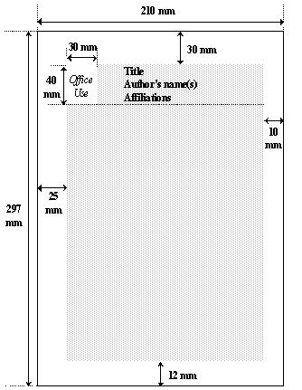
Fig.1 Margins for the Abstract template.
The abstract should be completed within 1 page with figures, tables and references. As the submitted abstract will be printed and reproduced directly without any editing, special care should be taken to ensure high quality of text and diagrams.
The abstract should be sent via e-mail (spacc21-gs@spacc.gr.jp) to Dr. Tomohiro Yamaguchi with “Presentation for SPACC-21/IFAEE-1 #submission ID” as the subject, and “#submission ID + name” as the file name. The submission ID is a five-digit number starting from 2, such as “2xxxx”. Only Acrobat PDF files will be accepted. The deadline for abstract submission would be September 15.
Fig.2 Kogakuin University
(Tokyo Urban Tech).
Table 1 Important date.
Date | Event
September 15, 2014 | Abstract deadline
xxx | xxx

[1] A. Author and B. Author: “Title of paper,” Journal Name, vol., startpage-endpage (year).
[2] A. Author, Title of book (Publisher), Chapter, (year).

